Day 3 Treasure Hunt

We’ve made it to siku tatu (Day 3) of The Incredible Race, racers!

You may look for the treasures either inside or outside, but stay away from the parking lot and the pond.

To complete your hunt, you may work alone or in a group. If you are working alone, find the same number of items as your age. For instance, if you are ten years old, complete any of the ten challenges on the list below. If you are working in a group, you must complete at least twelve of the activities. You’ll need a Bible.

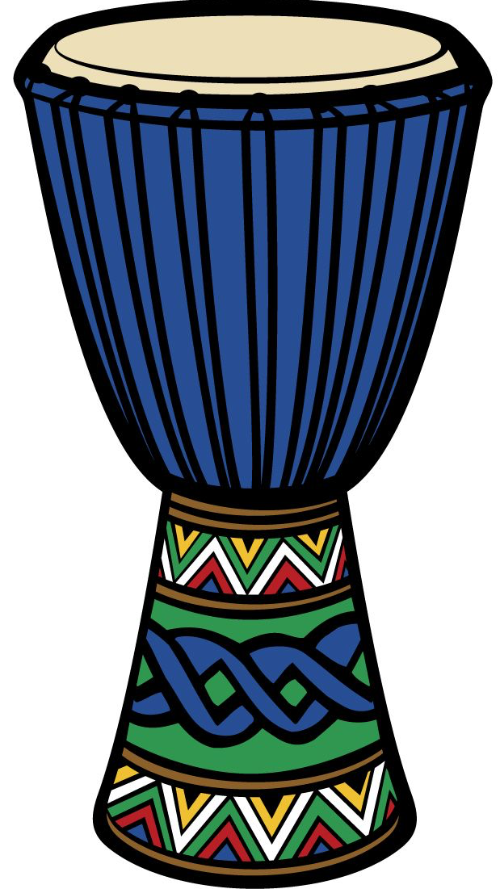
You have until 6:15 pm to complete the hunt and bring your items and list to the prize counter. One prize per person. No prizes will be given out after 6:15.
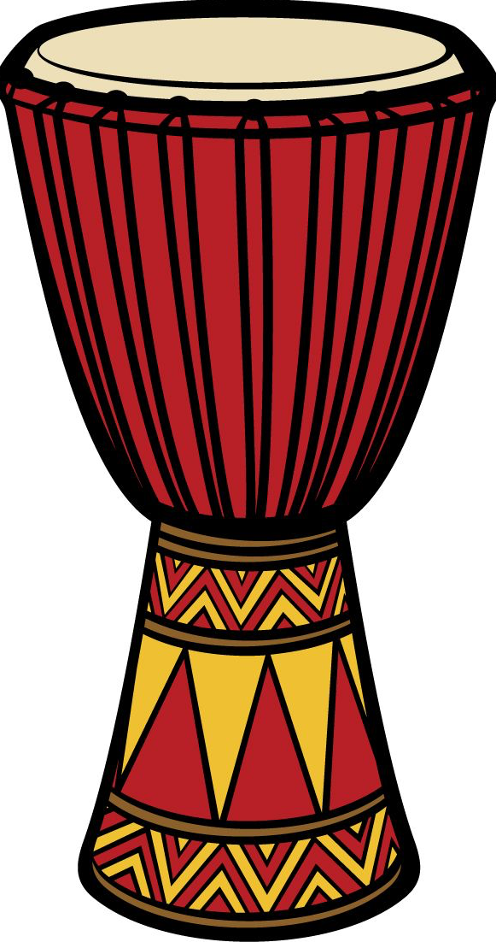

Ready, set, GO!

- Does the Nile River run north or south? Write the answer here. _________________

- Find two items that are two different shades of the color blue. Put them in your bag.

- Look up Acts 17:26. What’s the eighth word of the verse? Write it here. ______________________________

- Find someone who has been to Africa. Have them sign here. _______________________________________________________

- Find the country of Sudan on a map. Write a country that is next to it here. ____________________________________________

- Find someone who has a dog. Have them write their dog’s name here. _______________________________________________________

- Carry something that isn’t breakable on your head for 15 steps. Check off once completed. _____

- Find a small twig or stick. Put it in your bag.

- Find someone wearing a necklace. Have them sign here. ______________________________________________________

- Find someone who plays the drums. Have them sign here. ______________________________________________________

- Find one item that’s smaller than a quarter. Put it in your bag.

- Draw a flag from an African country on your bag.

- Make a mini pyramid out of items you find. Include the items in your bag.

- Find something that could float on water. Put it in your bag.

- Run in place for 30 seconds while saying over and over, “I am fearfully and wonderfully made!” (Psalm 139) Check off once you have done this. _____

