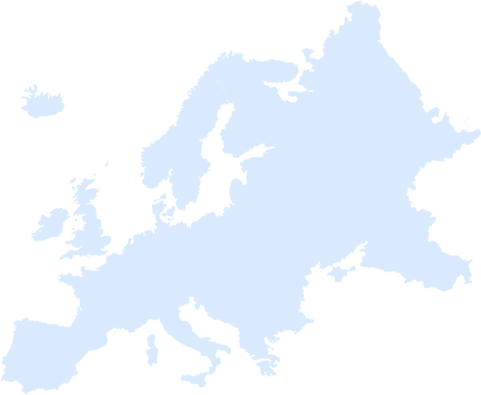

Day Four Intro Challenge

Find five mini Eiffel Towers around the building.

If you do, your leader can circle a country on your Europe score card.

