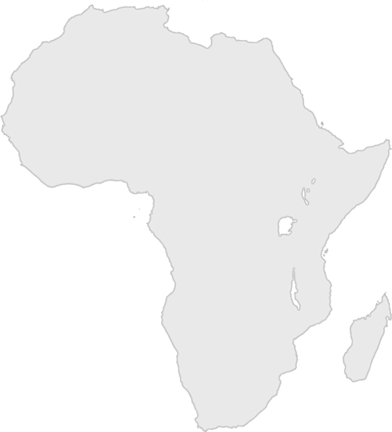
Day Three Bible Clue

Question: What color would you call this African boy’s skin? (See the poster.)

