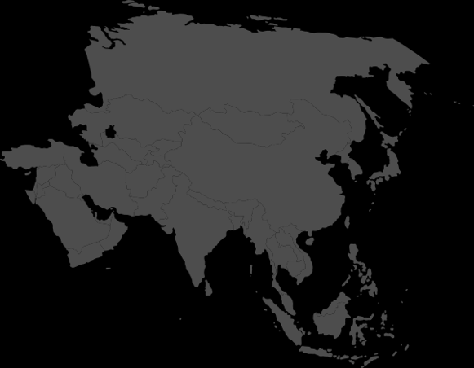
Day Two Bible Clues

Option 1
Question: Your challenge had to do with building a tower. Genesis 11 talks about a tower we refer to as the tower of Babel. What does the tower of Babel have to do with Asia, our continent of the day?

Option 2
Question: Your challenge had to do with writing an Asian word. What do you think Asia has to do with the tower of Babel?

