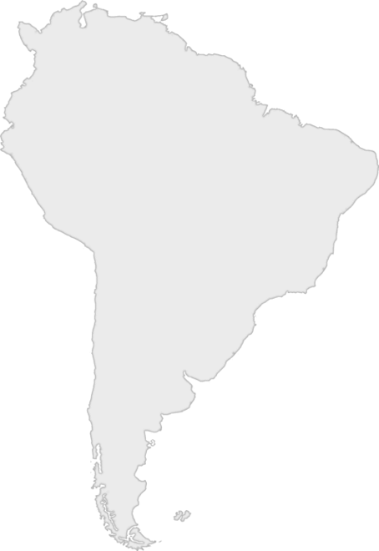
Day One Bible Clue

Question 1: Who ate a fruit when they were told not to?

Question 2: What book of the Bible is this account found in?

