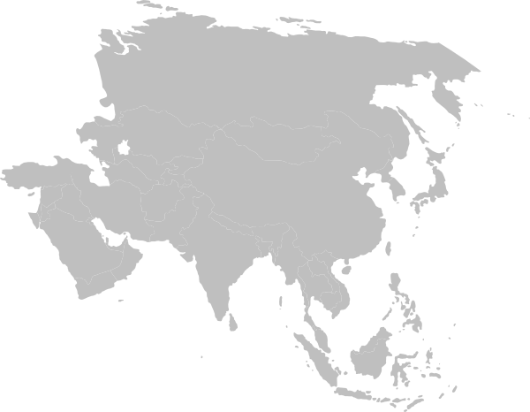
Day 2 Challenge Sheet

Have the racers stretch up higher and higher and shout out the answers to the following.

- Our animal pal today is Jamal the _____.
- Our Bible verse says: Its name was called _____.
- The people at the tower of Babel were not obeying _____.
- At the tower of Babel, the people started talking in different _____.
- The people had to move all over the _____.

