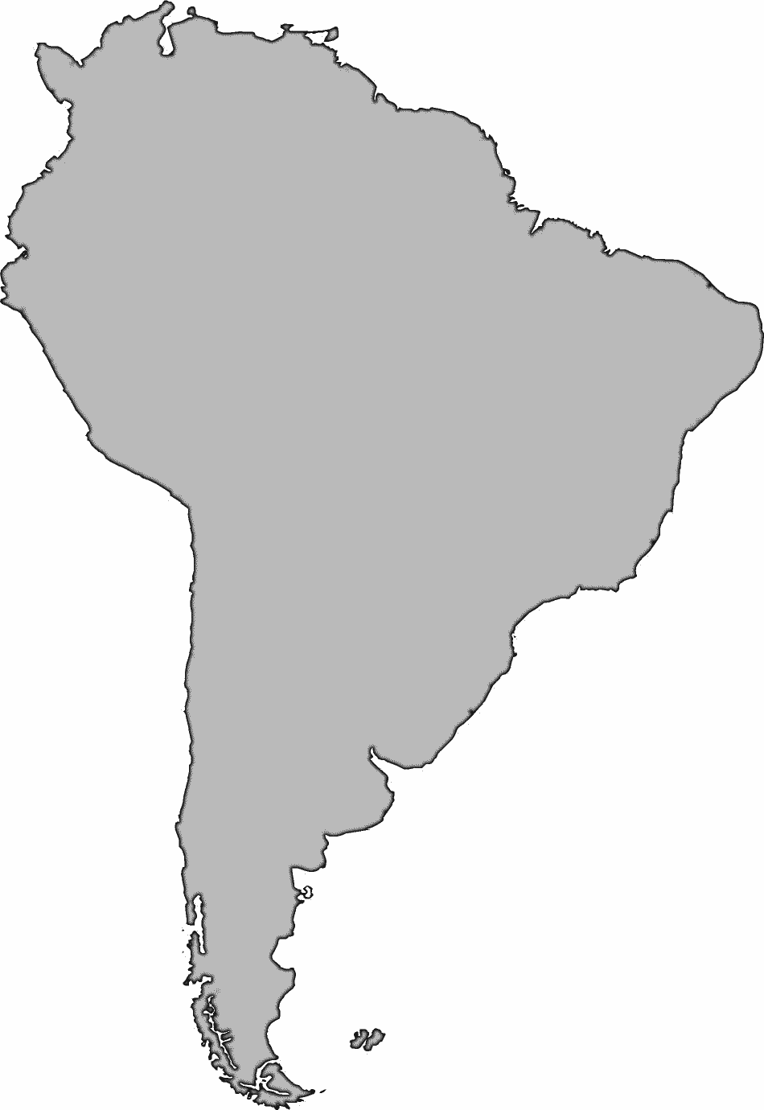

Day 1 Challenge Sheet

Have the racers jog in place and shout out the answers to finish the phrases below.

- Adam and _____
- Cain and _____
- Noah built the _____
- Tower of _____
- Bo the _____
- All have _____

