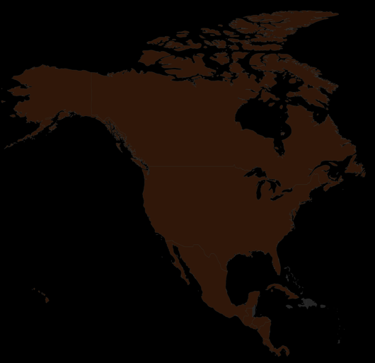
Day Five Snack Challenge

Option 2: Candy World
North America is famous for many candy inventions. In today’s challenge, you’ll review the candy challenge poster and identify at least two candy types that were not invented in North America.

If you complete the task within 30 seconds, your leader can circle a country on your North America score card.

