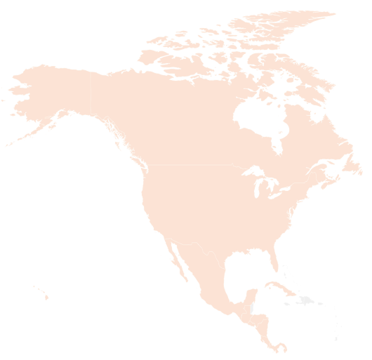
Day Five Craft Challenge

Option 2: Find the Flag
Look around the room and identify at least three flags that are from North American countries.

If you complete the challenge in less than two minutes, your leader can circle a country on your score card.

