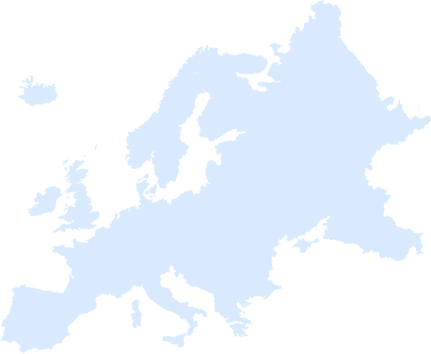
Day Four Game Challenge

Option 1: Ten in Ten
Racers, your leader is going to count to ten in French, a language from Europe. While your leader counts, you will try to do ten push-ups in ten slow seconds.

If at least half of you complete this challenge before the counting is done, your leader can circle a country on the Europe score card.

Counting to Ten in French
un - [ahn] - (one)
deux - [deuh] - (two)
trois - [twah] - (three)
quatre - [katr] - (four)
cinq - [sank] - (five)
six - [seese] - (six)
sept - [set] - (seven)
huit - [wheat] - (eight)
neuf - [nurf] - (nine)
dix - [deese] - (ten)

