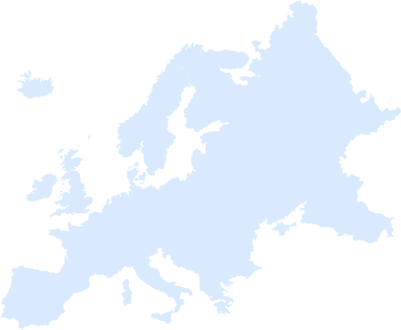
Day Four Craft Challenge

Option 2: Things are Looking Up
Draw a clip art shape while on your back.

If everyone completes the challenge in the allotted time, your leader can circle a country on the score card.

