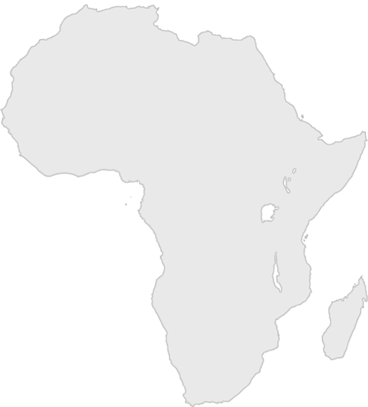
Day Three Snack Challenge

Option 2: African Animals
Leaders: Do this challenge after you’re done with your drinks. Don’t throw away your water bottles or cups.

To win this challenge, your team needs to have at least five different African animal stickers on the bottom of your cups. Each team member should look on the bottom of his/her cup, and the team leader will count the different types of animals represented.

If the team has at least five different animals, your leader can circle a country on the Africa score card.

