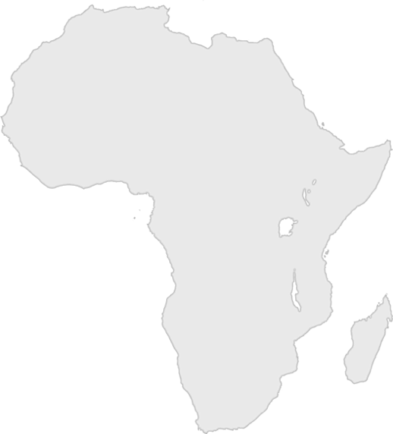

Day Three Intro Challenge

Find three African animal pictures around the building.

If you do, your leader can circle a country on your Africa score card.

