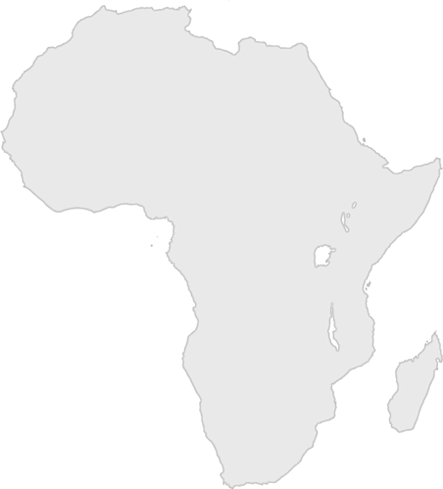
Day Three Game Challenge

Option 1: Ten in Ten
Racers, your leader is going to count to ten in Swahili, a language from Africa. While your leader counts, you will try to do ten sit-ups in ten slow seconds.

If at least half of you complete this challenge before the counting is done, your leader can circle a country on the Africa score card.

Counting to Ten in Swahili
moja - [mow-ja] - (one)
mbili - [bee-lee] - (two)
tatu - [tat-two] - (three)
nne - [nn-eh] - (four)
tano - [ta-no] - (five)
sita - [see-ta] - (six)
saba - [saw-ba] - (seven)
nane - [gnaw-nay] - (eight)
tisa - [tea-sa] - (nine)
kumi - [coo-me] - (ten)

