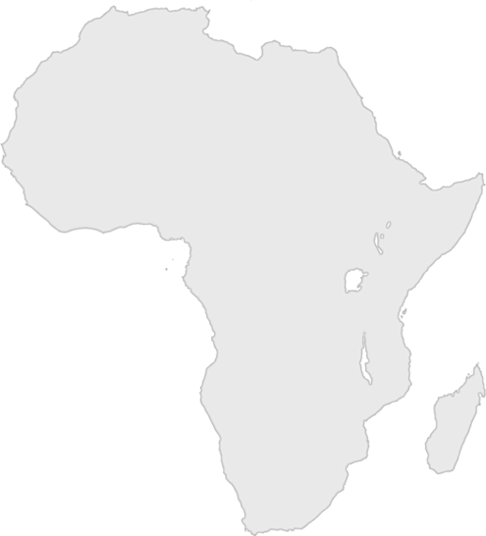
Day Three Craft Challenge

Option 2: It’s Shade Time
Arrange the shades of color in order from lightest to darkest.

If you complete the challenge in a minute or less, your leader can circle a country on the score card.

