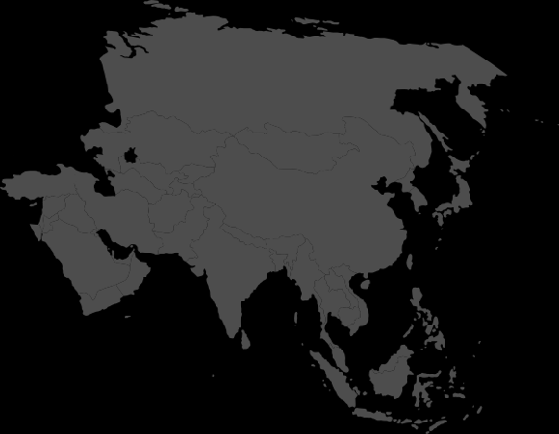

Day Two Intro Challenge

Find two flags around the building from countries in Asia.

If you do, your leader can circle a country on your Asia score card.

