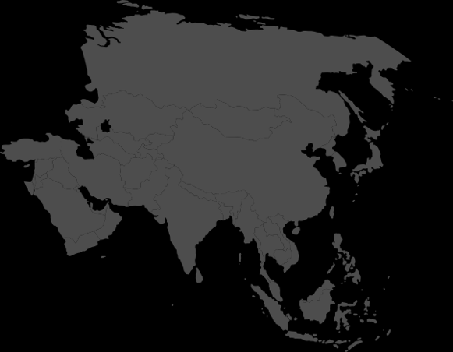
Day Two Craft Challenge

Option 2: “Jesus” in Many Languages
Write the beloved name "Jesus" in different languages.

If at least half the team can get three written (besides “Jesus” in your own language) in two minutes, your leader can circle a country on the score card.

