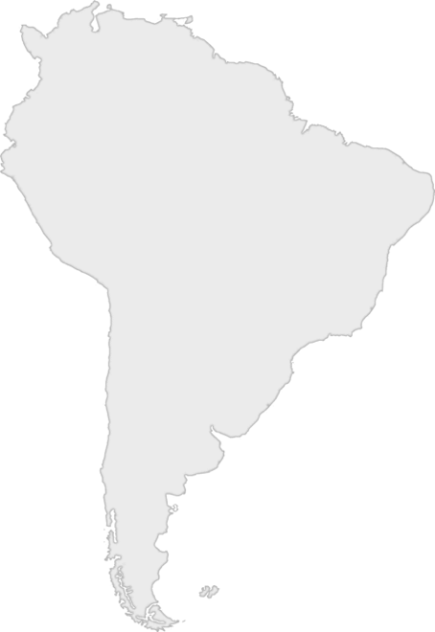
Day One Snack Challenge

Option 2: Find It
Rice and beans are staples of many meals in South America. Your challenge is to find the hidden piece of rice (or bean) in a bin of rice (or beans).

If you find it in the allotted time, your leader can circle a country on your South America score card.

