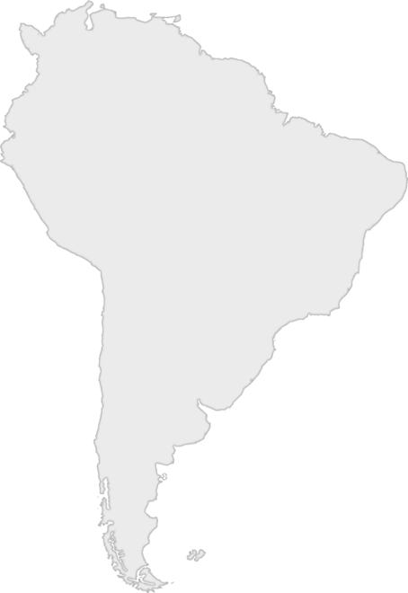
Day One Game Challenge

Option 1: Ten in Ten
Racers, your leader is going to count to ten in Spanish, a language that is spoken in South America. While they do, you will try to do ten jumping jacks in ten seconds.

If at least half of you complete this challenge before the counting is done, your leader can circle a country on the South America score card.

Counting to Ten in Spanish

uno - [oo-no] - (one)
dos - [dose] - (two)
tres - [trace] - (three)
cuatro - [quat-row] - (four)
cinco - [sink-o] - (five)
seis - [say-s] - (six)
siete - [see-et-ay] - (seven)
ocho - [o-cho] - (eight)
nueve - [new-ev-ay] - (nine)
diez - [dee-ez] - (ten)

